Reference: 2111127-01-02-03-04-05
Custom sheet: 22105970

TEST REPORT nº 221.I.2111.1176.ES.02

AT THE REQUEST OF:
COMPANY: | CANTISA, S.A.
RESPONSABLE: | D. JOSE LUIS RICO/JUAN JOSE HERRERO
ADDRESS: | POLÍGONO CUIDAD MUDECO C/PINTOR SOROLLA, 8
TOWN: | 46930 QUART DE POBLET (VALENCIA)
TELÉPHONE: | 96.159.72.42
CIF (VAT number): | A-46.269.213

RELATING TO:
SAMPLES: | SCEW COVERS AND WOOD PORE SUPPORT
TEST: | SURFACE ADHERENCE

DATE OF RECEIPT OF SAMPLES: | 16/11/2021
START DATE OF TRIALS: | 16/11/2021
TESTING END DATE: | 19/11/2021

Document digitally signed by legal electronic signature.

El presente informe anula y sustituye al informe nº 221.I.2111.1176.ES.01. Cambio respecto a la anterior versión: se omite la denominación comercial de los productos ensayados.

THIS REPORT CONSISTS OF 4 CORRELATIVELY NUMBERED PAGES.

The test sample object of this report will remain in AIDIMME for a period of three months from the date of issue of the same. Once this period has elapsed, it will be destroyed, therefore any claim must be made within these limits.

AIDIMME. INSTITUTO TECNOLÓGICO METALMECÁNICO, MUEBLE, MADERA, EMBALAJE Y AFINES

Parque Tecnológico - Calle Benjamín Franklin, 13
CIF: ESG46261590-46980 PATERNA (Valencia) ESPAÑA aidimme@aidimme.es
Tel: 96 136 60 70 - Fax: 96 136 61 85 www.aidimme.es

TEST REPORT n° 221.I.2111.1176.ES.02

- DESCRIPTION AND IDENTIFICATION OF THE TESTED SAMPLE.
PRE-TEST INSPECTION

PVC adhesive caps with the following characteristics according to the client's indication:
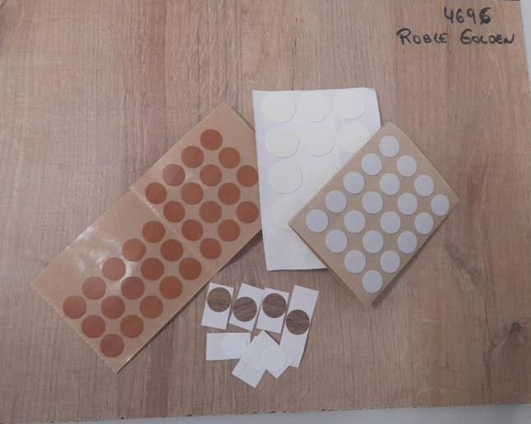
  - Adhesive caps Nº1 in white color and 20mm diameter.
  - Adhesive caps Nº2 of gray color and 13mm diameter.
  - No. 3 adhesive caps with cherry design and 13mm diameter.
  - Cantisa sample 1 white adhesive caps with squared support and 14mm diameter.
  - Cantisa adhesive caps sample 2 of walnut design with white support and 14mm diameter.

ORIGIN OF THE SAMPLE

Samples supplied by the customer.

- REQUESTED TEST
Traction adhesion.

- ADEQUATENESS OF THE TEST TO THE STANDARD

The test method carried out is based on what is indicated in the UNE-EN 311:2002 standard “Wood-derived boards. Starting from the surface of the boards”, after adhering the caps on a wood pore melamine board shown in the previous photograph.

TEST REPORT n° 221.I.2111.1176.ES.02

TEST METHOD

SURFACE TENSILE STRENGTH

Square test pieces are obtained from the laminated board provided by the company. On the face of the pieces, the adhesive caps are adhered to the central part and they are kept for a period of 24 hours under normal conditions of humidity and temperature (23 °C - 50 %RH).
Subsequently, they are glued, using a cyanoacrylate-type adhesive, to a standardized steel cylinder so that only the surface of the cap remains adhered to the cylinder. The force required to remove the adhesive plug from the deck surface is then measured using a universal tensile testing machine.
The pull-out resistance value of the SS surface is calculated, expressed in N/mm2, according to:

SS = F
A

F is the maximum force in Newton
A is the surface of each cover cap in mm2

This value is calculated for each cap adhered with an approximation of 0.01 N/mm2.

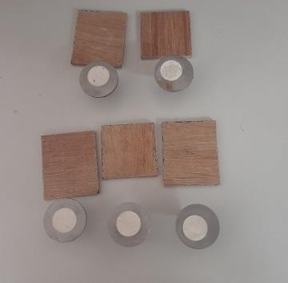
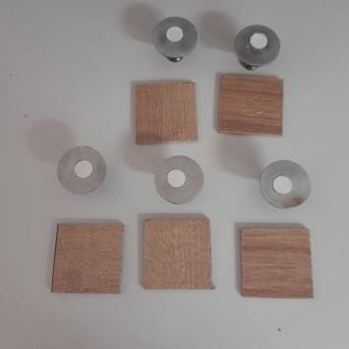
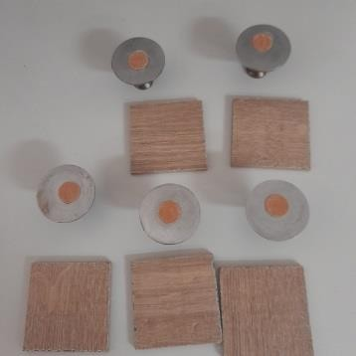

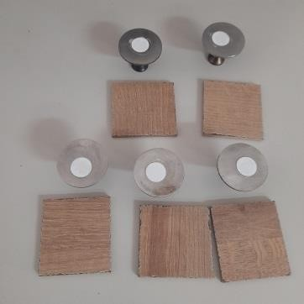
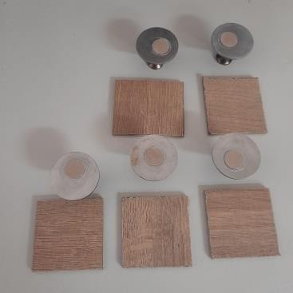
Photographs: State of the test specimens once subjected to the tensile test.

TEST REPORT n° 221.I.2111.1176.ES.02

RESULTS OBTAINED

REFERENCE | Surface tensile adhesion (N/mm2)
Adhesive cap Nº1 | 0,15 (0,01)
Adhesive cap Nº2 | 0,30 (0,01)
Adhesive cap Nº3 | 0,27 (0,07)
Cantisa Adhesive cap 1 | 0,29 (0,07)
Cantisa Adhesive cap 2 | 0,37 (0,13)
Note: The standard deviation of the measurements is indicated in parentheses.

The result of the present test(s) concerns only the object(s) tested.

LINK TO THE ORIGINAL DOCUMENT:

https://cantisa.es/wp-content/uploads/2021/12/Ensayo-AIDIMME_Adherencia-Tapones.pdf

